Reservation wise Resource and VM Report

# Overview

It provides detailed report of resource consumption which includes storage, memory, CPU and VM Quota .It prepares a report which concern about resource consumption by a BG’s reservation i.e. it provides creation, allocation and utilization of resources along with the VM details by a reservation.

# Goal

It is prepared to ease out the process of analyzation of resource consumption by a BG.

# Solution /Logic design

Execute action “getBG”

bgprop.put(bg ID, bg Name)

VCACCAFE

HOST

Get reservations and fetch subtenant id of a bg

If (bgprop.get(

subtenant id) == given bg )

Fetch name of the reservations belongs to that BG and other details like extension data

allocatedResources = allocatedMemory +”:”+allocatedStorage +”:”+allocatedQuota ;

allocatedMap.put(reservationName, allocatedResources )

Initialize the maps as well createdMap.put(resName,"0:0:0:0");

runningMap.put(resName,"0:0:0:0");

first value is memory, second value is storage, third value is vm count and fourth one is cpu

Execute action “getOCfromVmProperties”

Get OC of BG

If resources.name == OC

Execute action “getResourcesOfBG”

Get resources of BG

Fetch vms of the BG along with other details ip address of the vm, reservation name, operating system, owner, cpu, memory & storage

vmDetails.push(reservationName,vmname,os,cpu,memory,storage,state,ipAddress,owner)

vmDetails.sort()

For each reservation

Calculate created and running data(sums up storages, memories, CPUs and quota for all the VM of a reservation) and update the createdMap and runningMap with the new values

Iterate the maps allocated, running and created to get the individuals value of storage, cpu, memory and quota according to a reservation

reservations.push(allocated Storage, allocated memory, allocated quota,created memory,storage,quota,cpu,running memory,running quota,created storage,running cpu) and reservations.sort()

finalArray = reservations.concat(vmdetails)

Write data to file through action”write dataToFile” and send the file with the mail through action “send mail”

end

# properties included

**RESERVATIONS PROPERTIES**

* Reservation Name - different reservations of a BG.
* Allocated Quota – how much VM quota is provided to a particular reservation.
* Allocated Memory – how much memory is allocated to a reservation.
* Allocated Storage – how much storage is allocated to a reservation.
* Created Memory – how much memory has been used up by a reservation
* Created Storage- how much Storage has been used up by a reservation
* Created CPU - how much CPU has been used up by a reservation
* Created Quota – how many VMs has been created by a reservation
* Running Memory – how much memory is currently in use.
* Running Quota - how many VMs are running currently.
* Running Storage – how much memory is currently in use.
* Running CPU – how many CPUs are in use currently.

**RESERVATION WISE VM PROPERTIES**

* Reservation Name – Host reservation name i.e. under which reservation a particular VM has been created.
* VM Name – Name of the VM
* Operating System – OS of the VM.
* CPU – CPU occupied by a VM
* Storage – Storage occupied by a VM.
* Memory – Memory occupied by a VM
* IP Address – IP address of the VM
* Owner – who owns a VM

Dependencies

# Related Actions

* WriteDataToTheFile – It writes the requested data to the provided file.
* ValidateEmail – It validates the mail Address.
* listBG – It provides the one with all the business group exists in AD as a predefined list of elements.
* getBG – It fetches the desired business group and store it in a map with Name as a value and id as its value.
* GetOCfromVMproperties - get OC value of a BG( we are working with the substring of OC here) through VM properties.
* getResourcesOfBG - get all the resources i.e. services, custom templates, VMs, blueprints related to a particular bg.
* getProvisioningGroupEntityByName – It gets the entity set of provisioning group properties related to a VM from vCentre.

# Related Configuration elements

* VcacHost – host through which VRO connect with IAAS services of VRA to fetch the required data.
* VcacCafeHost – host through which VRO connect with VRA to fetch the required data.
* SmtpHost – with which one will be able to connect to the server to send the mail.
* CcAddress – it includes other member’s mail address to whom requester wants to send the mail.
* smtpPort - with which one will be able to connect to the server to send the mail.

# Attributes

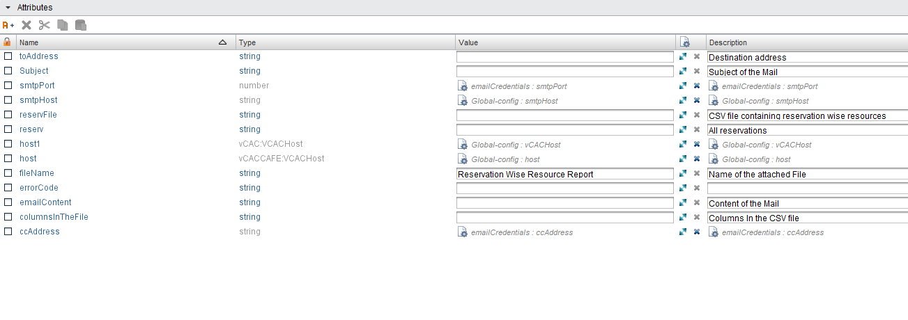

# Inputs

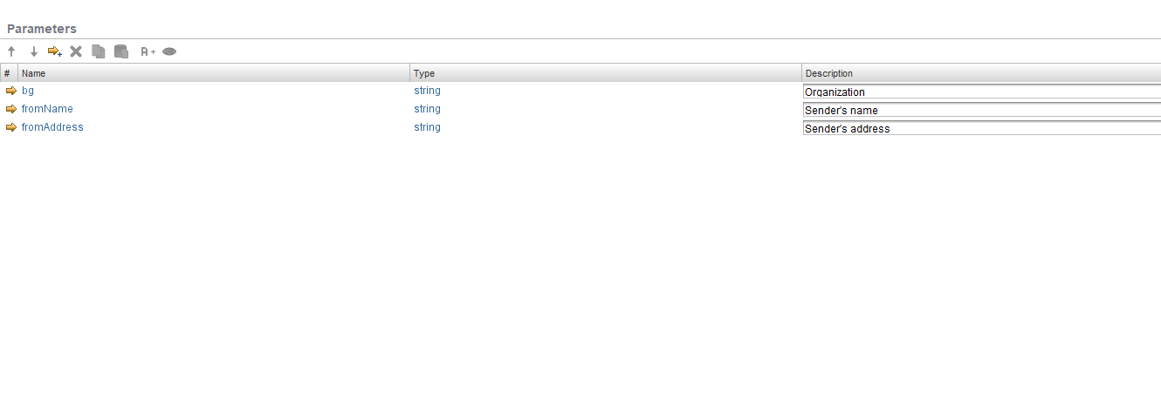

# Future scope

Nothing till yet